**GIT COMMANDS**

**Performing git commands:**

1.Authenticating your git account

**git config --global user.email “shajo.502152@sxcce.edu.in”**

**git config --global user.name “Shajo777”**

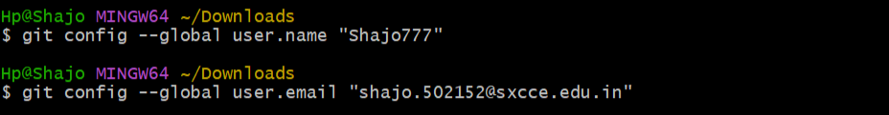

2.Initializing a Git repository

**git init**

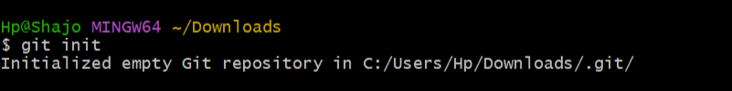

3. Cloning a repository

**git clone** [**https://github.com/Shajo777/devops.git**](https://github.com/Shajo777/devops.git)

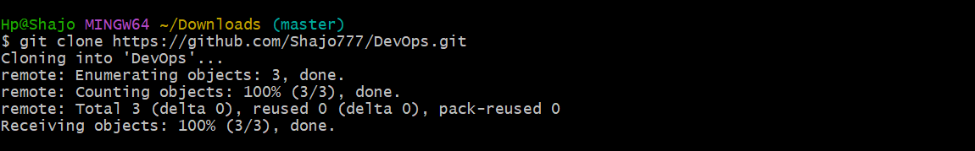

4. Getting status of repo:

**git status**

